DVD Rental Business Insights

This comprehensive report provides an analysis of our DVD rental business, encompassing a variety of critical metrics and insights, reflecting our operations’ health, customer engagement, and overall financial performance. The contents are structured to offer a summarized breakdown of customer activity, revenue generation, inventory utilization, and popularity metrics of our rental inventory by rental category.

**Customer Activity Analysis**: The report begins with an in-depth exploration of customer rental patterns, highlighting trends in customer preferences and frequency of rentals. This section provides a clearer understanding of our customer base and their engagement levels throughout the year.

**Revenue Overview**: A detailed examination of the revenue streams from rentals. This includes analysis of peak periods, comparison of month over month performance, and identification of the employees responsible for that revenue.

**Inventory Utilization And Performance**: Our analysis on inventory utilization offers a look into the efficiency of our current stock management. It identifies the rates at which different categories of DVDs are rented out, helping pinpoint areas where inventory adjustments may be beneficial. This section will also look at the most and least popular DVDs based on rental frequency. By understanding customer preferences, we can tailor our purchasing and promotional strategies to better align with demand.

**Procedures and Queries**: To ensure transparency and reproducibility of our findings, the report concludes with a detailed description of the procedures and SQL queries used to extract data from the “dvdrental” database. This part serves as a valuable resource for those interested in diving deeper into the data used to create this report. .

This report aims to equip stakeholders with the knowledge required to make informed decisions and to continue enhancing our service offerings to meet customer demands effectively.

**Customer Activity Analysis**

2005 - 2006 saw a total of 599 customers that took out 16,044rentals, with the most rentals being in July ‘05 and the least rentals being February ‘06. A detailed month over month breakdown by customer is available in the database as a separate detailed report. Information on how to access this data is in the Procedures and Queries section.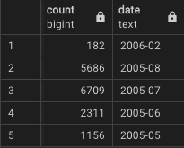

5686 rentals in August ’05

6709 rentals in July ’05

2311 rentals in June ’05

1156 rentals in May ’05

182 rentals in February ‘06

**Revenue Overview**

This same period saw a total revenue of 61,312 with $30,252 coming from store 1 and $31,059 coming from store 2. Each store only has 1 employee wich is also the manager of that store making Mike Hillyer responsible for store 1, and Jon Stephens responsible for store 2.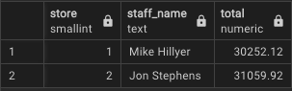

Note: store 1 total inventory is 2270, store 2 is 2311. Even accounting for inventory difference store 2 has slightly higher overall performance. Store 1 ultimately had generated $13.32 per dvd in their inventory while store 2 generated $13.43

**Inventory Utilization**

Company wide, 99.97% of the dvd inventory was rented out at least once, with the only non-utilized inventory being a single copy of ‘Academy Dinosaur’. I do believe this to be random happenstance but would also like to take the opportunity to point out the importance of ensuring a proper rotation of inventory at all times to maximize the longevity of our inventory. I would consider anything above 95% to be excellent.

Overall the company had a very predictable spread in terms of rental popularity as the most popular rental categories also had the most available inventory across all stores. There are a few exceptions to this however such as action being 0.18% more popular than science fiction even though they have the same inventory, and Drama being 2.94% more popular than Foreign.

*Count of rentals by category*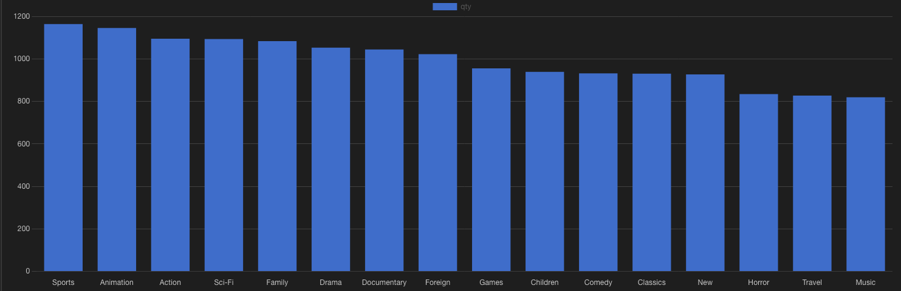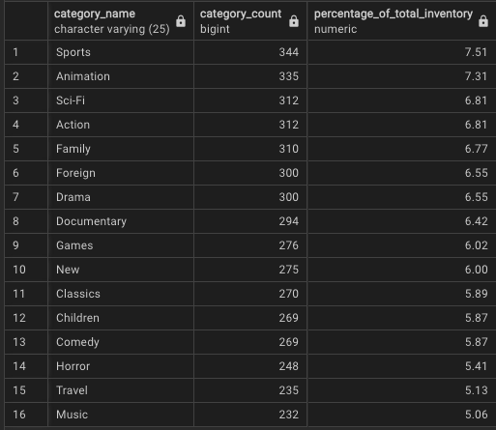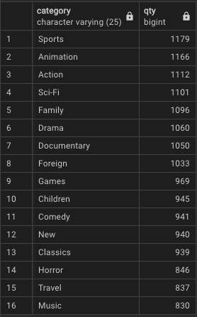

*Inventory Breakdown By Category*

*Count of rentals by category*

Next if we look at popularity by individual titles, the least Popular Rentals of our current inventory are Hardy Robbers, Mixed Doors, and Train Bunch, all with 4 rentals each and the overall most popular rental was Bucket Brotherhood with 34 rentals.

*Top 20*   *Bottom 20*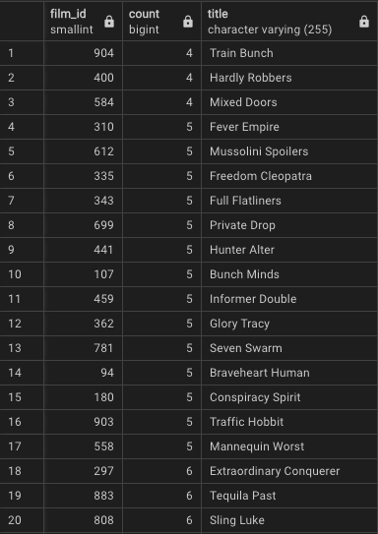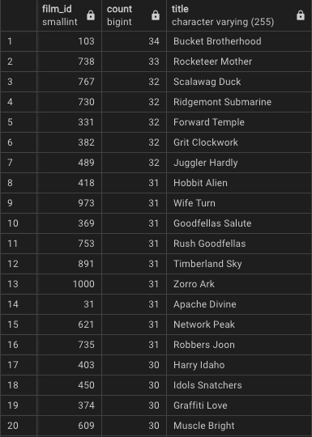

Lastly lets look at a performance metric for each category. This “performance” number is derived by dividing the number of rentals by the available inventory for that category to create a ratio of rentals:inventory per category. This data can be used to determine wich categories we should focus on expanding the most moving foreward as a higher number means the movies are rented out more frequently relative to their available inventory. For example horror is a low performer and a low popularity, ranking 14th by customer rental count and 16th by performance with it being 14th on our inventory percentage list. By contrast Music is a category that stands out as something we should consider increasing the total inventory of. Even though it ranks dead last on customer rental quantity, this is likely due to low availability as it is the 2nd highest performing category and the smallest percentage of the overall inventory, meaning it would be worth looking into increasing the overall inventory of music related films.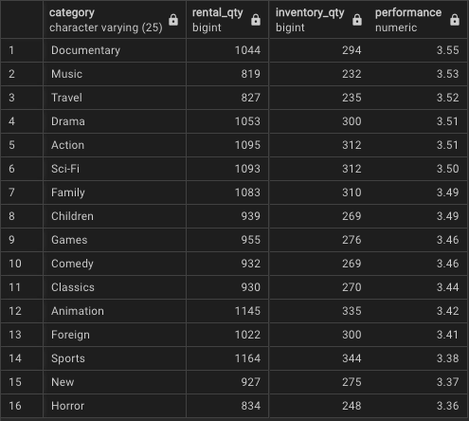

**Procedures And Queries**

Analysis of the DVD Rental Database begins with adding the ‘tablefunc’ module for PostgreSQL databases to have access to the crosstab feature, allowing the use of pivot tables.Screenshot 2024-05-19 at 2.30.23 PM.png

Next create the pivot table.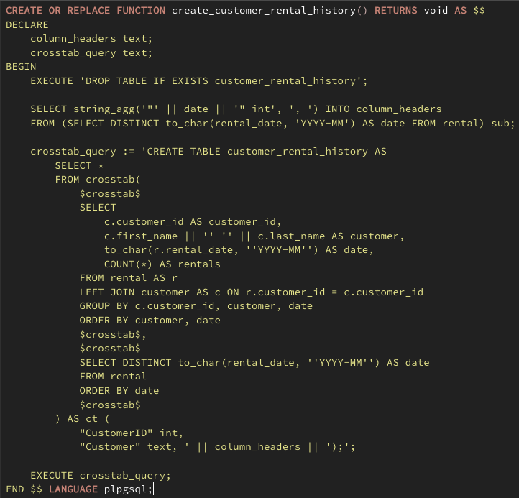

The query pictured above creates a pivot table from a dataset consisting of customer rental data aggregated by customer and month of activity. First column is the customers ID followed by their name, concatenated for ease of reading, and 1 column for each month in wich there is rental data with the customers rental count for that month. Now while seeing each individual customers rental history is a useful starting point for a lot of reports and does simplify reviewing account history on a customer by customer basis, this table can be aggregated further to provide a month over month report for total number of rentals per month, and if this report were to be run every year it could be used to provide important data on the habits of individual customers over time.

However if you are only interested in the total number of rentals month over month this can be achieved from the base table “public.rental” with the following query.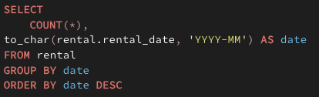

The basis of the pivot table was made after aggregating customer data into a new table called customer_rentals_by_month wich was created with the following query: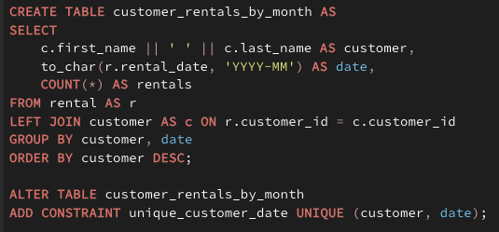

This table has a stored procedure to update it over time although it is ultimately non-essential to the pivoted table.

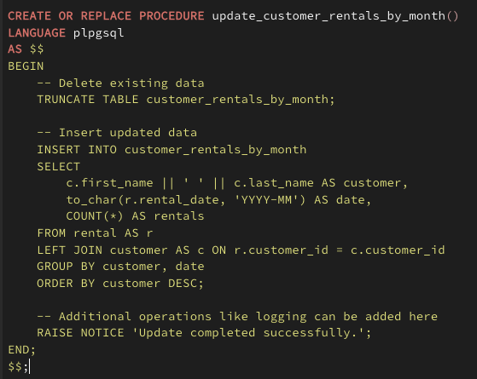

The customer_rentals_by_month table is intended to provide long term year over year tend analysis of customer rentals on a per customer basis wich would be most useful for creating some kind of loyalty rewards points system based on number of rentals over time.

For the category breakdowns listed in the report summary there are a few queries that will be useful.

Rental Count By Category: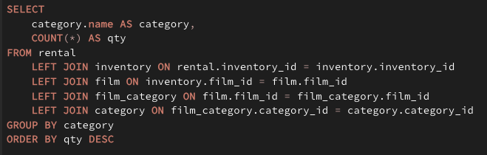

Performance by category: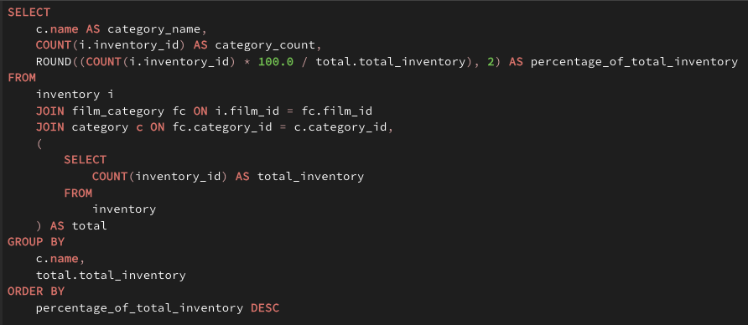

And the 2 of those combined is what I would use to interpret categorical performance in the future: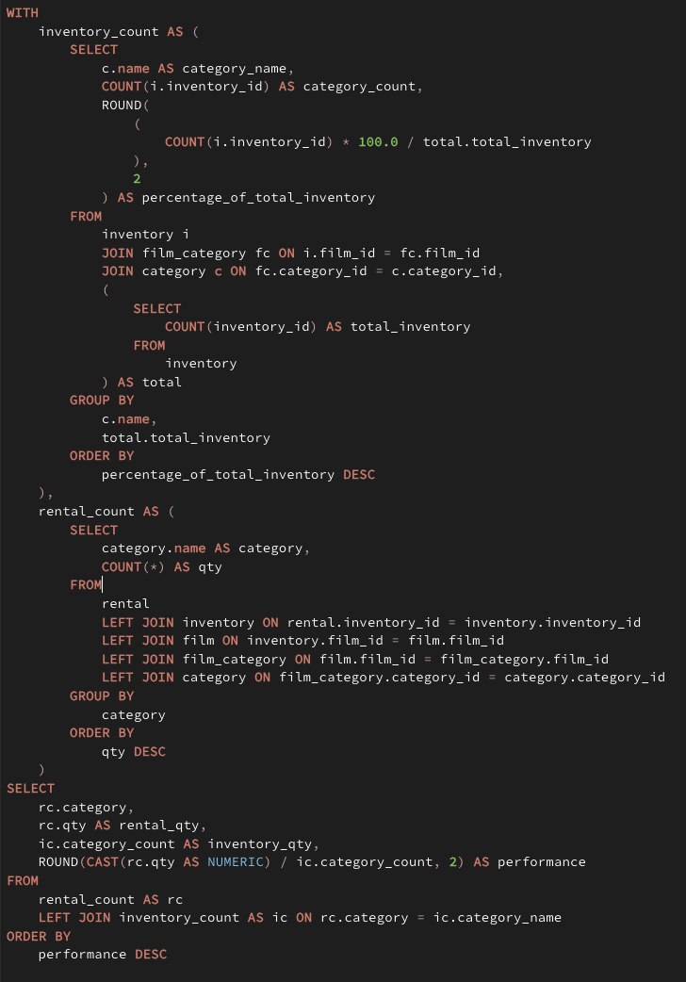

Financial Performance By Employee: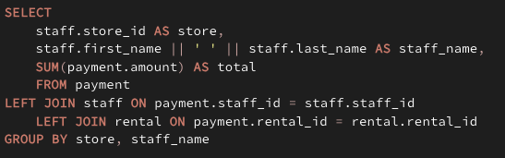

Count of rentals by film: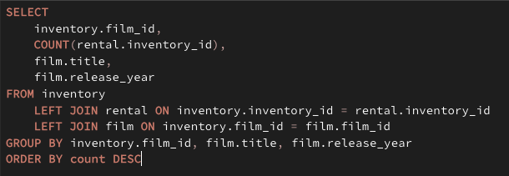

Note: there appears to be a major incongruity in the database in that every film in the film table has a release year of 2006, even the films that were rented in 2005. Also the payment dates for rentals in 2005 are all registered in 2007 wich again raises some concerns about the integrity of the data. I had intended to do a more in-depth financial breakdown for 2005, but as the transaction data dates do not line up with rental dates that was not possible to accurately compose.

**Query Appendix**

**—Count of rentals by film**

SELECT

inventory.film_id,

COUNT(rental.inventory_id),

film.title,

film.release_year

FROM inventory

LEFT JOIN rental ON inventory.inventory_id = rental.inventory_id

LEFT JOIN film ON inventory.film_id = film.film_id

GROUP BY inventory.film_id, film.title, film.release_year

ORDER BY count DESC

**—Inventory Performance By Category**

SELECT

c.name AS category_name,

COUNT(i.inventory_id) AS category_count,

ROUND((COUNT(i.inventory_id) * 100.0 / total.total_inventory), 2) AS percentage_of_total_inventory

FROM

inventory i

JOIN film_category fc ON i.film_id = fc.film_id

JOIN category c ON fc.category_id = c.category_id,

(

SELECT

COUNT(inventory_id) AS total_inventory

FROM

inventory

) AS total

GROUP BY

c.name,

total.total_inventory

ORDER BY

percentage_of_total_inventory DESC

**—Count rentals by month**

SELECT

to_char(r.rental_date, 'YYYY-MM') AS date,

COUNT(*) AS rentals

FROM rental AS r

GROUP BY date

ORDER BY date DESC

**—Count rentals by category**

SELECT

category.name AS category,

COUNT(*) AS qty

FROM rental

LEFT JOIN inventory ON rental.inventory_id = inventory.inventory_id

LEFT JOIN film ON inventory.film_id = film.film_id

LEFT JOIN film_category ON film.film_id = film_category.film_id

LEFT JOIN category ON film_category.category_id = category.category_id

GROUP BY category

ORDER BY qty DESC

**—Count rentals by film**

SELECT

inventory.film_id,

COUNT(rental.inventory_id),

film.title

FROM inventory

LEFT JOIN rental ON inventory.inventory_id = rental.inventory_id

LEFT JOIN film ON inventory.film_id = film.film_id

GROUP BY inventory.film_id, film.title

ORDER BY count DESC

**—Revenue per employee**

SELECT

staff.store_id AS store,

staff.first_name || ' ' || staff.last_name AS staff_name,

SUM(payment.amount) AS total

FROM payment

LEFT JOIN staff ON payment.staff_id = staff.staff_id

LEFT JOIN rental ON payment.rental_id = rental.rental_id

GROUP BY store, staff_name

**—Create Category/Inventory Performance Table**

**\***note: not really needed since the procedure already does this but its not a bad idea to create the table first or to have a manual backup for reference in case someone edits the procedure incorrectly.

CREATE TABLE inventory_performance AS

WITH

inventory_count AS (

SELECT

c.name AS category_name,

COUNT(i.inventory_id) AS category_count,

ROUND(

(COUNT(i.inventory_id) * 100.0 / total.total_inventory), 2

) AS percentage_of_total_inventory

FROM

inventory i

JOIN film_category fc ON i.film_id = fc.film_id

JOIN category c ON fc.category_id = c.category_id,

(

SELECT

COUNT(inventory_id) AS total_inventory

FROM

inventory

) AS total

GROUP BY

c.name,

total.total_inventory

ORDER BY

percentage_of_total_inventory DESC

),

rental_count AS (

SELECT

category.name AS category,

COUNT(*) AS qty

FROM

rental

LEFT JOIN inventory ON rental.inventory_id = inventory.inventory_id

LEFT JOIN film ON inventory.film_id = film.film_id

LEFT JOIN film_category ON film.film_id = film_category.film_id

LEFT JOIN category ON film_category.category_id = category.category_id

GROUP BY

category

ORDER BY

qty DESC)

SELECT

rc.category,

rc.qty AS rental_qty,

ic.category_count AS inventory_qty,

ROUND(CAST(rc.qty AS NUMERIC) / ic.category_count, 2) AS performance

FROM

rental_count AS rc

LEFT JOIN inventory_count AS ic ON rc.category = ic.category_name

ORDER BY performance DESC;

**— Create update_inventory_performance Stored Procedure**

CREATE OR REPLACE PROCEDURE update_inventory_performance()

LANGUAGE plpgsql

AS $$

BEGIN

EXECUTE 'DROP TABLE IF EXISTS inventory_performance';

EXECUTE '

CREATE TABLE inventory_performance AS

WITH

inventory_count AS (

SELECT

c.name AS category_name,

COUNT(i.inventory_id) AS category_count,

ROUND((COUNT(i.inventory_id) * 100.0 / total.total_inventory), 2

) AS percentage_of_total_inventory

FROM

inventory i

JOIN film_category fc ON i.film_id = fc.film_id

JOIN category c ON fc.category_id = c.category_id,

( SELECT

COUNT(inventory_id) AS total_inventory

FROM

inventory

) AS total

GROUP BY

c.name,

total.total_inventory

ORDER BY

percentage_of_total_inventory DESC ),

rental_count AS (

SELECT

category.name AS category,

COUNT(*) AS qty

FROM

rental

LEFT JOIN inventory ON rental.inventory_id = inventory.inventory_id

LEFT JOIN film ON inventory.film_id = film.film_id

LEFT JOIN film_category ON film.film_id = film_category.film_id

LEFT JOIN category ON film_category.category_id = category.category_id

GROUP BY

category

ORDER BY

qty DESC)

SELECT

rc.category,

rc.qty AS rental_qty,

ic.category_count AS inventory_qty,

ROUND(CAST(rc.qty AS NUMERIC) / ic.category_count, 2) AS performance

FROM

rental_count AS rc

LEFT JOIN inventory_count AS ic ON rc.category = ic.category_name

ORDER BY

performance DESC;

';

END;

$$;

**—Create customer_rentals_by_month table**

* *Note: this was not needed by anything in the end and I only left it here because it was already done, and to serve as a backup example of stored procedures that is simpler than the inventory_performance.*

CREATE TABLE customer_rentals_by_month AS

SELECT

c.first_name || ' ' || c.last_name AS customer,

to_char(r.rental_date, 'YYYY-MM') AS date,

COUNT(*) AS rentals

FROM rental AS r

LEFT JOIN customer AS c ON r.customer_id = c.customer_id

GROUP BY customer, date

ORDER BY customer DESC;

ALTER TABLE customer_rentals_by_month

ADD CONSTRAINT unique_customer_date UNIQUE (customer, date);

**—Update customer rentals by month - Stored Procedure**

CREATE OR REPLACE PROCEDURE update_customer_rentals_by_month(new_customer_id int)

LANGUAGE plpgsql

AS $$

BEGIN

INSERT INTO customer_rentals_by_month (customer, date, rentals)

SELECT

c.first_name || ' ' || c.last_name AS customer,

to_char(NOW(), 'YYYY-MM') AS date, -- Assume we're updating for the current month

COUNT(*) AS rentals

FROM rental AS r

LEFT JOIN customer AS c ON r.customer_id = c.customer_id

WHERE c.customer_id = new_customer_id

GROUP BY customer, date

ON CONFLICT (customer, date) DO UPDATE

SET rentals = EXCLUDED.rentals;

RAISE NOTICE 'Update completed successfully.';

END;

$$;

**—Add in crosstab functionality**

CREATE EXTENSION IF NOT EXISTS tablefunc;

**— Add in pg_cron for task scheduling on Linux and MacOS**

* *Note: pg_cron works on Mac an linux but I was unable to make it work in windows, so instead I added the procedure to the trigger function that executes on insert into the rental table for this procedure.*

CREATE EXTENSION IF NOT EXISTS pg_cron;

SELECT cron.schedule('daily_update', '0 0 * * *', $$

BEGIN

PERFORM update_customer_rentals_by_month();

END $$);

**—Create scheduled task on Windows**

1. Create a file called psql_scheduled_tasks.sql and add the following content to that file:

CALL update_inventory_performance();

CALL update_customer_rentals_by_month();

2. Create a batch file called execute_stored_procedures.bat with the following content:

@echo off

psql -U your_username -d your_database -f “path\to\update_inventory_performance.sql"

3. Open Windows Task Scheduler, create a new task to run at midnight evey dat, and set the “Action” to start the batch file you just created.

**— Create function to create customer_rental_history crosstab/pivot table**

CREATE OR REPLACE FUNCTION create_customer_rental_history() RETURNS void AS $$

DECLARE

column_headers text;

crosstab_query text;

BEGIN

EXECUTE 'DROP TABLE IF EXISTS customer_rental_history';

SELECT string_agg('"' || date || '" int', ', ') INTO column_headers

FROM (SELECT DISTINCT to_char(rental_date, 'YYYY-MM') AS date FROM rental) sub;

crosstab_query := 'CREATE TABLE customer_rental_history AS

SELECT *

FROM crosstab(

$crosstab$

SELECT

c.customer_id AS customer_id,

c.first_name || '' '' || c.last_name AS customer,

to_char(r.rental_date, ''YYYY-MM'') AS date,

COUNT(*) AS rentals

FROM rental AS r

LEFT JOIN customer AS c ON r.customer_id = c.customer_id

GROUP BY c.customer_id, customer, date

ORDER BY customer, date

$crosstab$,

$crosstab$

SELECT DISTINCT to_char(rental_date, ''YYYY-MM'') AS date

FROM rental

ORDER BY date

$crosstab$

) AS ct (

"CustomerID" int,

"Customer" text, ' || column_headers || ');';

EXECUTE crosstab_query;

END $$ LANGUAGE plpgsql;

**—Execute function to create table**

SELECT create_customer_rental_history()

**— Select data from newly created table**

SELECT * FROM customer_rental_history;

**—Create trigger function to call stored procedure and recreate the customer_rental_history**

CREATE OR REPLACE FUNCTION call_update_customer_history() RETURNS trigger AS $$

BEGIN

CALL update_customer_rentals_by_month(NEW.customer_id);

PERFORM create_customer_history();

RETURN NEW;

END $$ LANGUAGE plpgsql;

**—Create event trigger to call trigger function on insert into rental table**

DROP TRIGGER IF EXISTS update_customer_history_after_insert ON rental;

CREATE TRIGGER update_customer_history_after_insert

AFTER INSERT ON rental

FOR EACH ROW

EXECUTE FUNCTION call_update_customer_history();

**— Insert new data into rental table to test if update functions work:**

INSERT INTO rental (customer_id, rental_date, inventory_id, staff_id) VALUES (1, '2024-05-01', 1, 1);

**Requirements Breakdown**

*\*Note: Emphasis is placed on the Category Performance aspect of the report to meet grading requirements.*

A. Real World Written Business Report: General Insights on inventory performance and customer rental history over time.

A1. category.name will be in the final summarized table of inventory_performance as well as the temp tables used to create that table.

A2. Data types of these fields are category - varchar(25), rentaly_qty - bigint, inventory_qty - bigint, and performance - numeric

A3. The tables used in inventory_performance are: inventory, film_category, category, rental, and film.

A4. Field that required specific manipulation was rc.qtywich is field from the temp table rental_count in the query to create the report. It was bigint but needed to be cast to numeric so I could get a non-integer value when diving rc.qty by ic.category (comes from temp table inventory_count). Since if you divide 2 integers psql will only output an integer and I wanted to display a float/decimal. If I hadn’t not done this every category would have had the same performance of 3 or 4 when that was not technically accurate.

A5. This report can be used to determine what rental categories are performing the best/worst and could be used to decide wich categories in the overall inventory should be expanded or refreshed the most. Also can be used to identify if any part of the inventory has lower performance than others indicating areas that would benefit the most from focussed improvement efforts.

A6. The table is set to be recreated every night at midnight using Windows Task Scheduler if your on windows, or pg_cron if your on Linux or MacOS

Note on section B: There are not permanent detailed view tables as they truly served no purpose other than to de-normalize the data wich is why I decided to create them solely as temp tables within the query to create the simplified view. If for any reason the detailed view of either of those tables is needed it is very easy to extract those queries and run them separately. This is a technique I use on a regular basis in my work to not clutter databases with duplicate de-normalized data.

All queries used to create this report and these tables, including the stored procedures and its triggers are located in the following GitHub repository:

https://github.com/cobalt88/DVD-Rental-EOY-2005